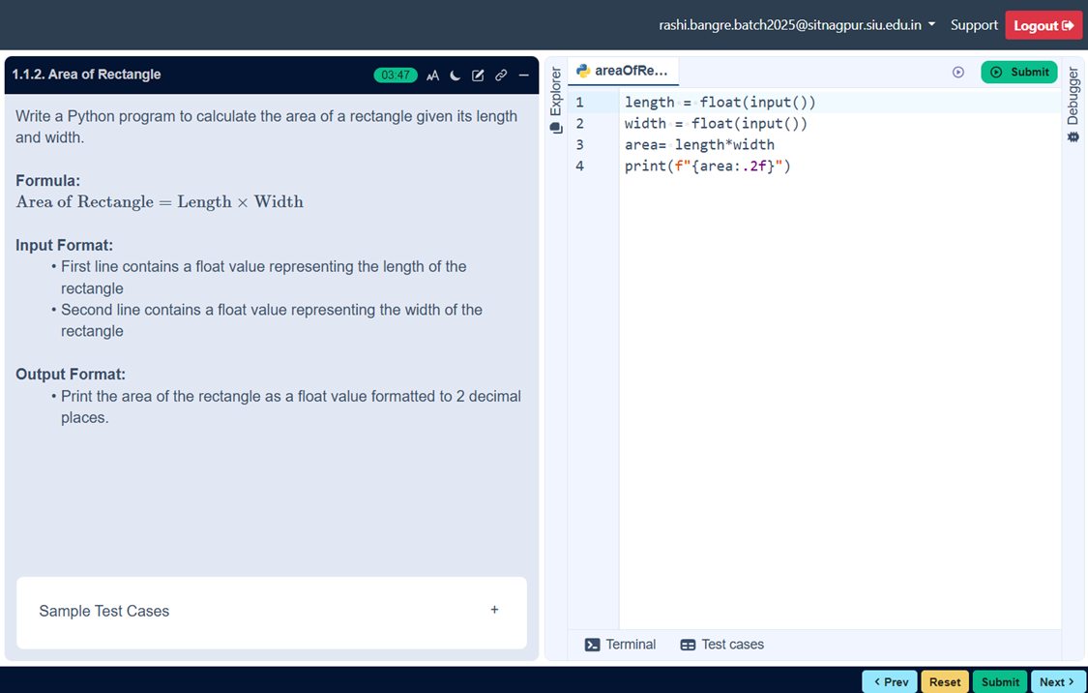
FLOWCHART

ALGORITHM
Step 1: Start
Step 2: Input length, breath
Step 3: Calculate
area=length*breath
Step 4: Print area
Step 5: Stop

AREA OF RECTANGLE
